**Weather Forecast Prediction:**

**ABSTRACT :**

Traditionally, climate assessment has been performed reliably by treating the environment as a liquid. The current wind condition is being observed. The future state of the environment is recorded by understanding thermodynamics and the numerical position of the liquid elements. Nevertheless, this traditional arrangement of differential conditions as observed by physical models is at times unstable under oscillating effects and uncertainties when estimating the underlying states of air. This indicates an insufficient understanding of environmental variations, so it limits climate forecasts to 10-day periods because climate projections are essentially unreliable. But machine learning is moderately hearty for most barometric destabilizing effects compared to traditional techniques. Another favorable position of machine learning is that it does not depend on the physical laws of environmental processes.

**Background:**

For the current situation, India observatory conducts traditional weather forecasting. There are four common methods to predict the weather. The first method is the climatology method that is reviewing weather statistics gathered over multiple years and calculating the averages. The second method is an analog method that is to find a day in the past with weather similar to the current forecast. The third method is the persistence and trends method that has no skill to predict the weather because it relies on past trends. The fourth method is numerical weather prediction the is making weather predictions based on multiple conditions in the atmosphere such as temperatures, wind speed, high-and lowpressure systems, rainfall, snowfall, and other conditions. So, there are many limitations of these traditional methods. Not only it forecasts the temperature in the current month at most, but also it predicts without using machine learning algorithms. Therefore, my project is to increase the accuracy and predict the weather in the future for at least one month by applying machine learning techniques

**Objective (Brief) :**

Purpose of this project is to predict the temperature using different algorithms like Linear Regression, Logistic Regression ,Decision Tree Regressor And Random Forest Regressor. The output value should be numerically based on multiple extra factors like maximum temperature, minimum temperature, cloud cover, humidity, and sun hours in a day, precipitation, pressure and wind speed.

**CONCLUSION:**

All the machine learning models: like Linear Regression, Logistic Regression ,Decision Tree Regressor And Random Forest Regressor. random forest regression were beaten by expert climate determining apparatuses, even though the error in their execution reduced significantly for later days, demonstrating that over longer timeframes, our models may beat genius professional ones. Linear regression demonstrated to be a low predisposition, high fluctuation model though polynomial regression demonstrated to be a high predisposition, low difference model. Linear regression is naturally a high difference model as it is unsteady to outliers, so one approach to improve the linear regression model is by gathering more information. Practical regression, however, was high predisposition, demonstrating that the decision of the model was poor and that its predictions can't be improved by the further accumulation of information. This predisposition could be expected to the structure decision to estimate temperature dependent on the climate of the previous two days, which might be too short to even think about capturing slants in a climate that practical regression requires. On the off chance that the figure was rather founded on the climate of the past four or five days, the predisposition of the practical regression model could probably be decreased. In any case, this would require significantly more calculation time alongside retraining of the weight vector w, so this will be conceded to future work. Talking about Random Forest Regression, it proves to be the most accurate regression model. Likely so, it is the most popular regression model used, since it is highly accurate and versatile. Below is a snapshot of the implementation of Random Forest in the project. Weather Forecasting has a major test of foreseeing the precise outcomes which are utilized in numerous ongoing frameworks like power offices, air terminals, the travel industry focuses, and so forth. The trouble of this determining is the mind-boggling nature of parameters. Every parameter has an alternate arrangement of scopes of qualities.

**Proofs:**

1. **LinearRegression:**

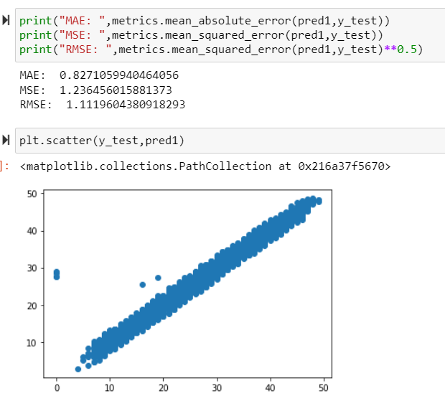

1. **DecisionTreeRegressor:**

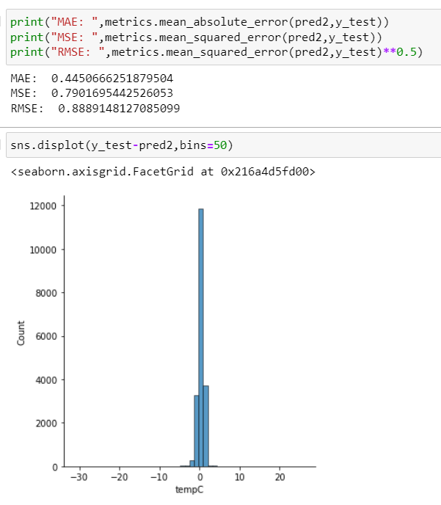

1. **RandomForestRegressor:**

